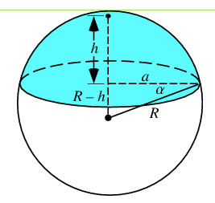
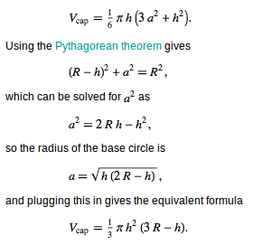



h: altura do corte

VOLUME:
a = sqrt(h * (2 * R - h));
V = (1.0/6.0) * PI * h *(3 * a * a – h * h)
V = 1/3 * PI * h * h * (3 * R - h)

SURFACE AREA:
S = 2 * PI * R * h
S = PI * (a * a – h * h)

ld volSphericalCap(esfera E, ld h){
return 1.0/3.0 * PI * h * h * (3 * E.r - h);
}

ld surfaceArea(esfera E, ld h){
return 2 * PI * E.r * h;
}

